**A**

**PROJECT REPORT**

**ON**

**ORGANIC CRATE**

Submitted in partial fulfillment for the award of

**Post Graduate Diploma in Advance Computing**

**(PG-DAC) from**

**INSTITUTE OF EMERGING TECHNOLOGIES**

**Authorized Training Centre**



**Under the Guidance of**

**Ashutosh Sonawane**

**BY**

**Dhanashree Botre – 03**

**Kanchan Jahagidar-06**

**Bhagyashree Patil-14**

**Shajal tiwari-23**



**CERTIFICATE**

This is to certify that the project report entitled **ORGANIC CRATE** is a bonfire work carried out by **Dhanashree Botre, Kanchan Jahagirdar, Bhagyashree Patil, and Shajal Tiwari** andsubmitted in partial fulfillment ofthe requirement for the C-DAC ACTS, DAC course in Institute of Emerging Technology in the batch of September 2020.

**Course Coordinator** **External Examiner**

(Mrunal Jalindre)

**ACKNOWLEDGEMENT**

This project **Organic Crate** was a great learning experience for us and we are submitting this work to Advanced Computing Training School (CDAC).

We are very glad to mention **Ashutosh Sonawane** for his valuableguidance to work on this project. His guidance and support helped us to overcome various obstacles and intricacies during the course of project work.

Our most heart full thanks goes to ***Mr. Sangram Patil*** **(Director ,IET)**who gave all the required support and kind coordination to provide all the necessities like required hardware , internet facility and extra lab hours to complete the project and throughout the course up to the last day here in C-DAC ACTS, Pune.

Sign of student

**Dhanashree Botre -03**

**Kanchan Jahagirdar-06**

**Bhagyashree Patil-14**

**Shajal Tiwari-23**

**Abstract**

This project is aimed at developing a web application that depicts online shopping of organic fruits, vegetables and grains for the patients who are dealing with corona, diabetes, blood pressure etc. It integrates the benefits of ordering products such as fruits, vegetables and grains with convenience of an online medium and going with the technology along with reducing one to one interaction with vendors and cutting down expenses of travelling. It provides a mean to collaborate E-ordering for the customers.

**Index**

|  |  |  |
| --- | --- | --- |
| **Sr. No.** | **Title** | **Page No.** |
| **1** | Introduction |  |
| **2** | Problem Definition & Scope |  |
| **2.1** | Problem Definition |  |
| **2.2** | Goals & Objectives |  |
| **2.3** | Major Constraints& Outcomes |  |
| **3** | Software Requirement Specification |  |
| **3.1** | Purposed System |  |
| **3.2** | Scope |  |
| **4** | System Modules |  |
| **5** | Performance-Requirements |  |
| **5.1** | H/W Requirements & S/W Requirements |  |
| **6** | UML Diagram |  |
| **6.1** | DFD |  |
| **6.2** | ERD |  |
| **6.3** | Use case diagram |  |
| **6.4** | Class Diagram |  |
| **6.5** | Sequence diagram |  |
| **6.6** | Activity Diagram |  |
| **6.7** | Deployment diagram |  |
| 6.8 | System Architecture |  |
| **7** | Test Cases |  |
| **8** | Screenshots |  |
| **9** | References |  |

**1. Introduction**

This project is aimed at developing a web application that depicts online shopping of organic fruits, vegetables and grains for the patients who are dealing with corona, diabetes, blood pressure etc. It integrates the benefits of ordering products such as fruits, vegetables and grains with convenience of an online medium and going with the technology along with reducing one to one interaction with vendors and cutting down expenses of travelling. It provides a mean to collaborate E-ordering for the customers.

Primarily here we focused on Organic food products as they cultivated without the use of synthetic fertilizers, radiation, pesticides or sewage residue. Now a days commonly available fruits, grains and vegetables are usually growned with use of chemical fertilizers, pesticides etc. When you consume such inorganic fruits and vegetables, those are harmful in long terms. Organic food is available at particular places in the market. Online shopping is a process of doing business through computer network where buyer can directly order products online while seller’s can sell their products by means of computer usually via the internet. We have proposed a best online organic store called **“Organic Crate”** which provides organic products online. Our application will take users requirements via the means of form where it will select it’s choices of fruits, vegetables and grains as their selected preferences and will submit it. On submission it will generate a product list which will match the users selected preferences.

Our application’s provides recommended products list to majorly people suffering with health issues who are not sure of regular food to be included in their daily routine. Moreover it provides facility to their customers who are not facing any medical issues. Here, one can carry out an online shopping from their home, as stepping out is not convenient option in covid19 pandemic. It helps the customer to book groceries from anywhere and any preferred time. There are lot of online grocery application existing in market who provide e-com facilities but very few intend to facilitate individual preferences. **“Organic crate”** surely aims to meet individuals organic food demand to control existing medical issues they have facing.

**2. Problem Definition & Scope**

2.1 **Problem Definition**

Looking at other web applications in market there is not enough of organic fruits and vegetables application for people dealing with health issues. Here we aim to deliver an application which will take care of requirements of users as per their health needs. We design our application in a manner where it will help its user to customize fruits, vegetables and grains suiting their medical dietary needs. We intent to help people who are looking to ease their search in market for fruits, vegetables and grains and get it delivered at their doorstep.

**2.2** **Goals & Objectives**

There are several objective of this application, It provides the facility to the customer who wants to buy **Organic products** such as fruits, vegetables and grains online. It helps in reducing one to one interaction with vendors and cutting down expenses of travelling. It’s provides all details about the Organic products like cost, weight, mfg. date and expiry date etc. It provides special facility of recommended Organic product list for the benefit of customer who has medical issue. It provides facility to the customer with payment option such as cash on delivery or Debit/Credit card or through Net banking.

**2.2** **Major Constrains And Outcomes**

The major Constraints occurred during the development of the project is Authorization of Role while logging in as Admin, User, Vendor and Patient.

The issue was to assign specific operations as per the role acquired after logging in.

So the outcome for the mentioned issues above was handled by Annotation based authorization (@EnabledGlobalMethodSecurity) by writing success handlers in WebSecurityConfiguration.

**3. Software Requirement Specification**

**3.1 Proposed System**

There are several objective of this application, It provides the facility to the customer who wants to buy Organic products such as fruits, vegetables and grains online. It helps in reducing one to one interaction with vendors and cutting down expenses of travelling.

It's provides all details about the Organic products like cost, weight, mfg date and expiry date etc.

It provides special facility of recommended Organic product list for the benefit of customer who has medical issue.

It provides facility to the customer with payment option such as cash on delivery or Debit/Credit card or through Net banking.

**3.2 Scope**

This application helps people with category dealing with medical issues and are not sure what kind of fruits, vegetables and grains to be included in regular diet. Our application’s target audience is majorly people who are not sure of regular food to be included in their daily routine. More over it provides facility to their customers who are not facing any medical issues.

**4. System Modules**

* **User module**
* Registration/Login : User registers and Logins to access application
* Customer details: User gives it details to proceed web application.
* Product booking: Selects product as per category.
* View product: Takes a look of the product selected.
* Give feedback: Gives Feedback regarding purchase.
* **Administrative module**
* Login : Admin registers and logins to the web application.
* Add Product: Adds products to Organic Crate as per category.
* Update Product: Updates products as per category.
* Delete Product: Deletes the product from Organic Crate Application.
* Manage customer orders: Admin is authorized to manage orders placed by customers.
* Views User List : Views User List in the organic crate Application.
* **Patient Module**
* Registration/Login: Patient Registers and Logins to access application.
* Patient details: Registers form to fill details and go through application.
* Product booking: Selects product as per category.
* View product: Takes a look of the product selected.
* Give feedback. : Gives Feedback regarding purchase.
* **Vendor**
* Add Product :Adds Product to the Organic Crate Application
* View Product : Views product added to the application.

**5. Performance Requirements**

**5.1 H/W Requirements & S/W Requirements**

* Front End
* Thymeleaf,html,css and bootstrap
* Middleware
* SpringMVCBoot,Java
* Back End
* MySQL

**6. UML Diagrams**

**6.1 DFD**

Level 0

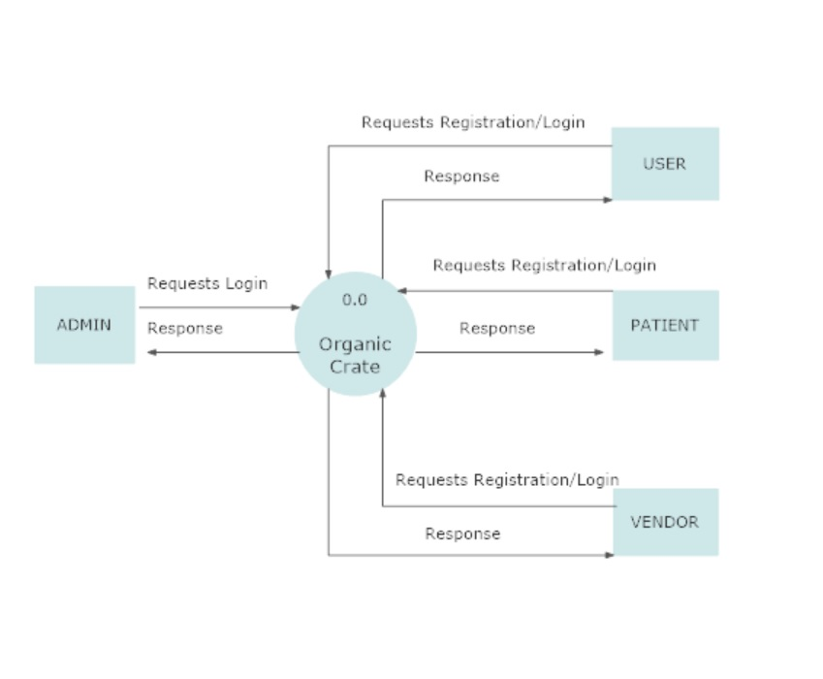

Vendor Side Level 1

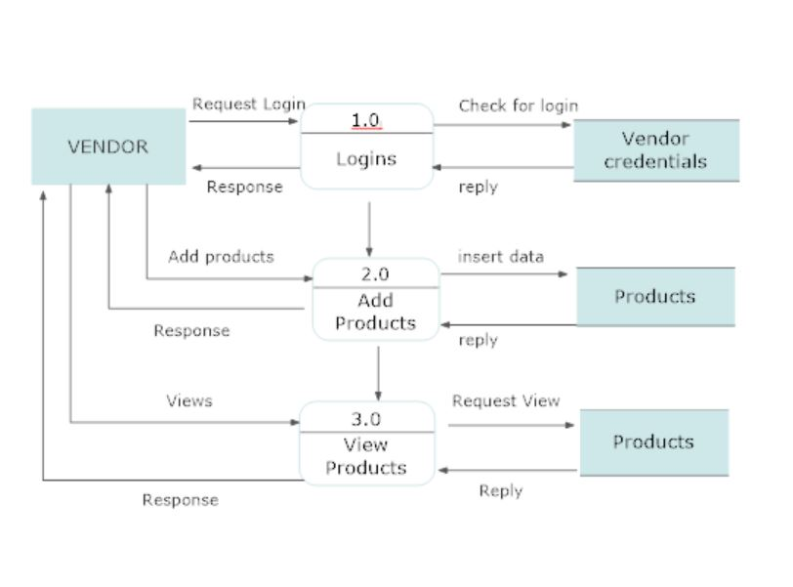

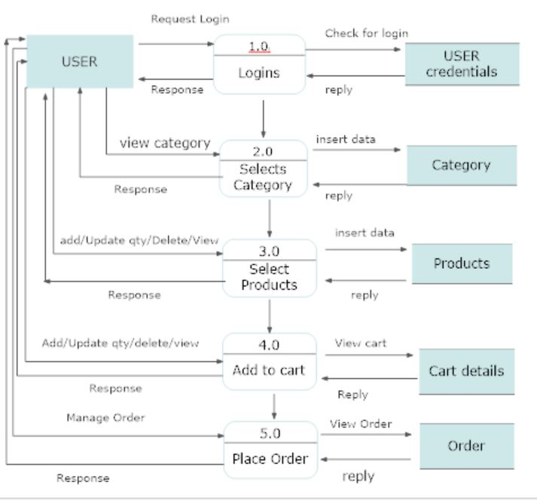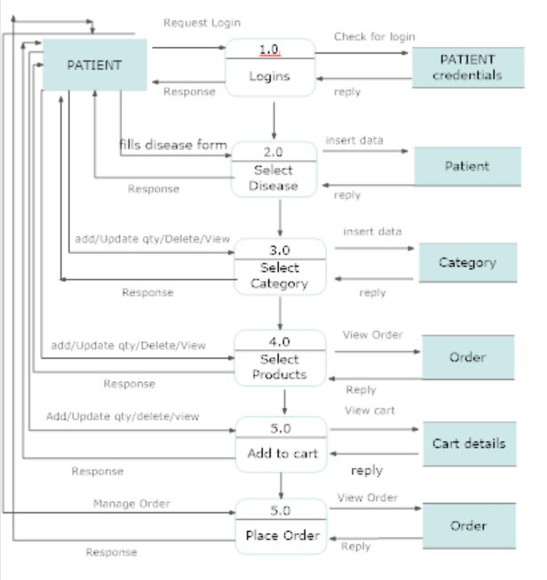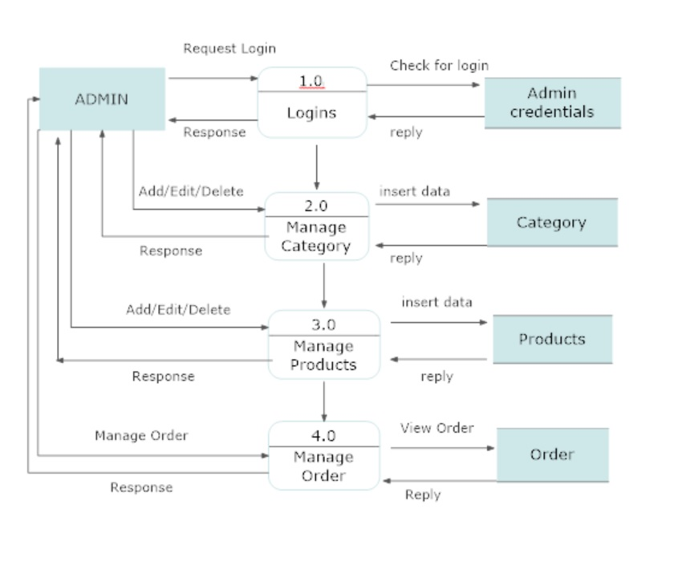

**6.2 ERD**

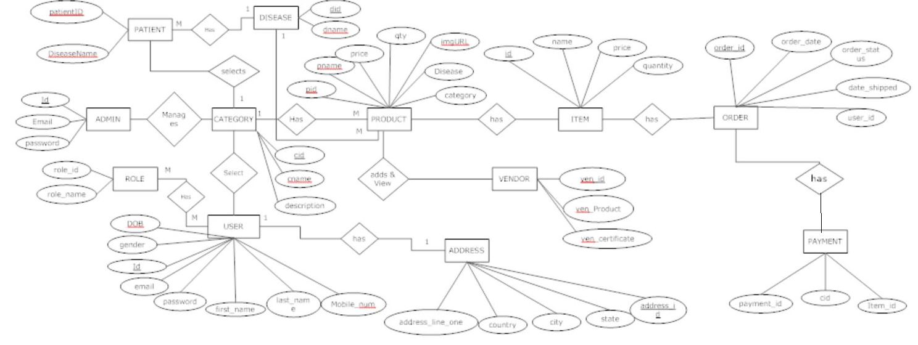

**6.3 Use Case Diagram**

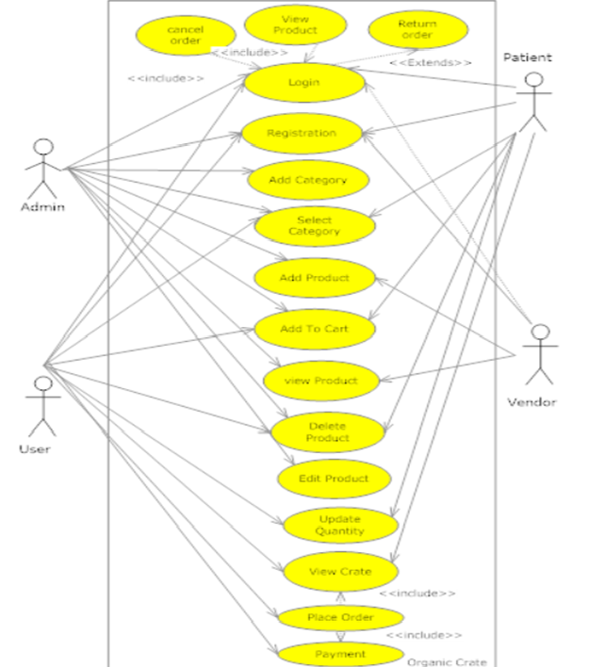

**6.4 Class Diagram**

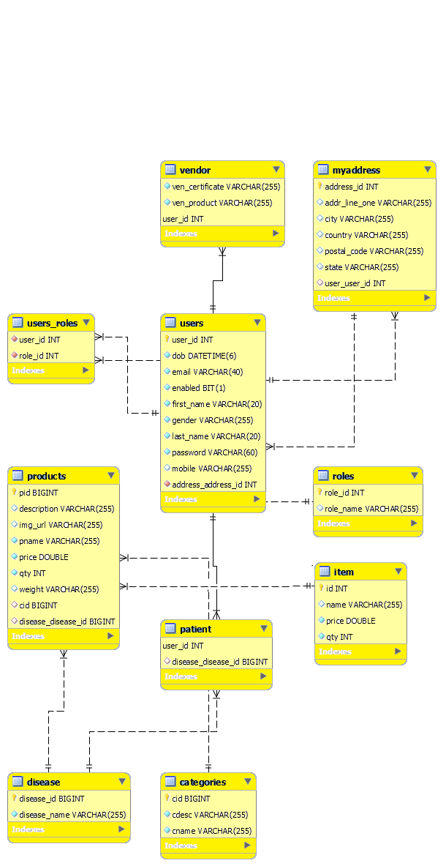

**6.5 Sequence Diagram**

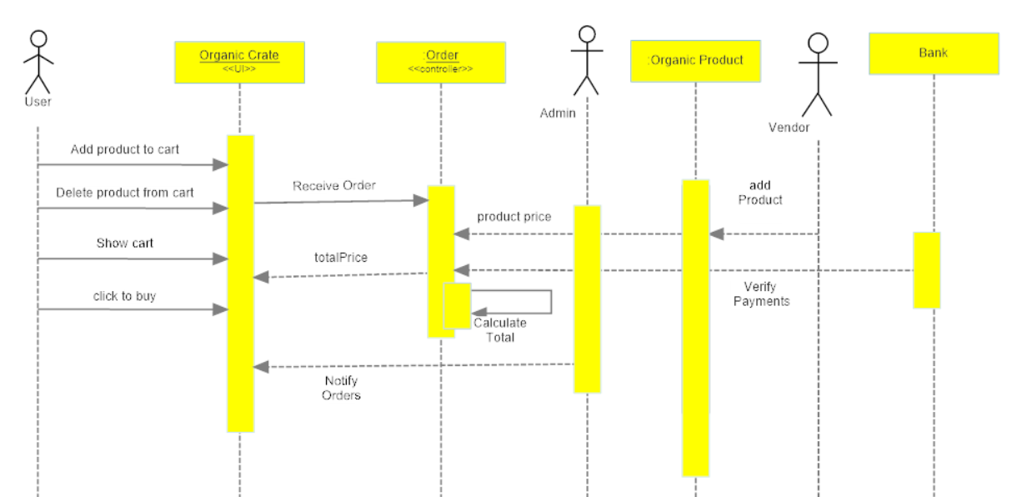

**6.6 Activity Diagram**

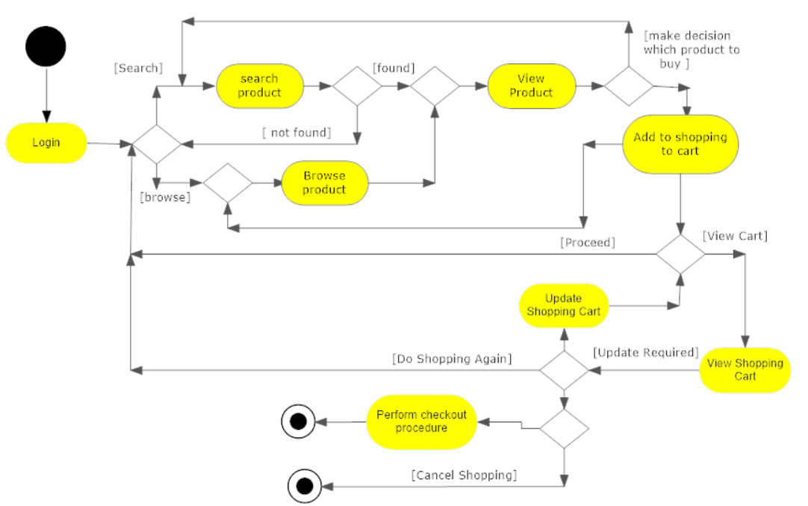

**6.7 Deployment Diagram**

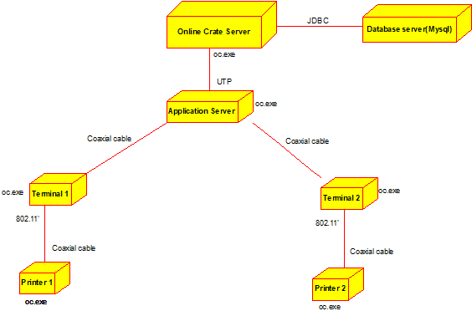

**6.8 System Architecture**

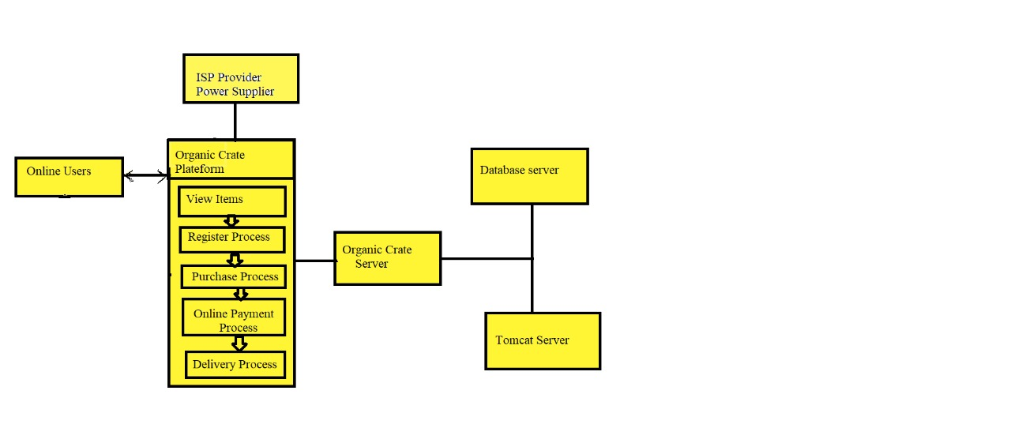

**7Test Cases**

**8 Screenshots**

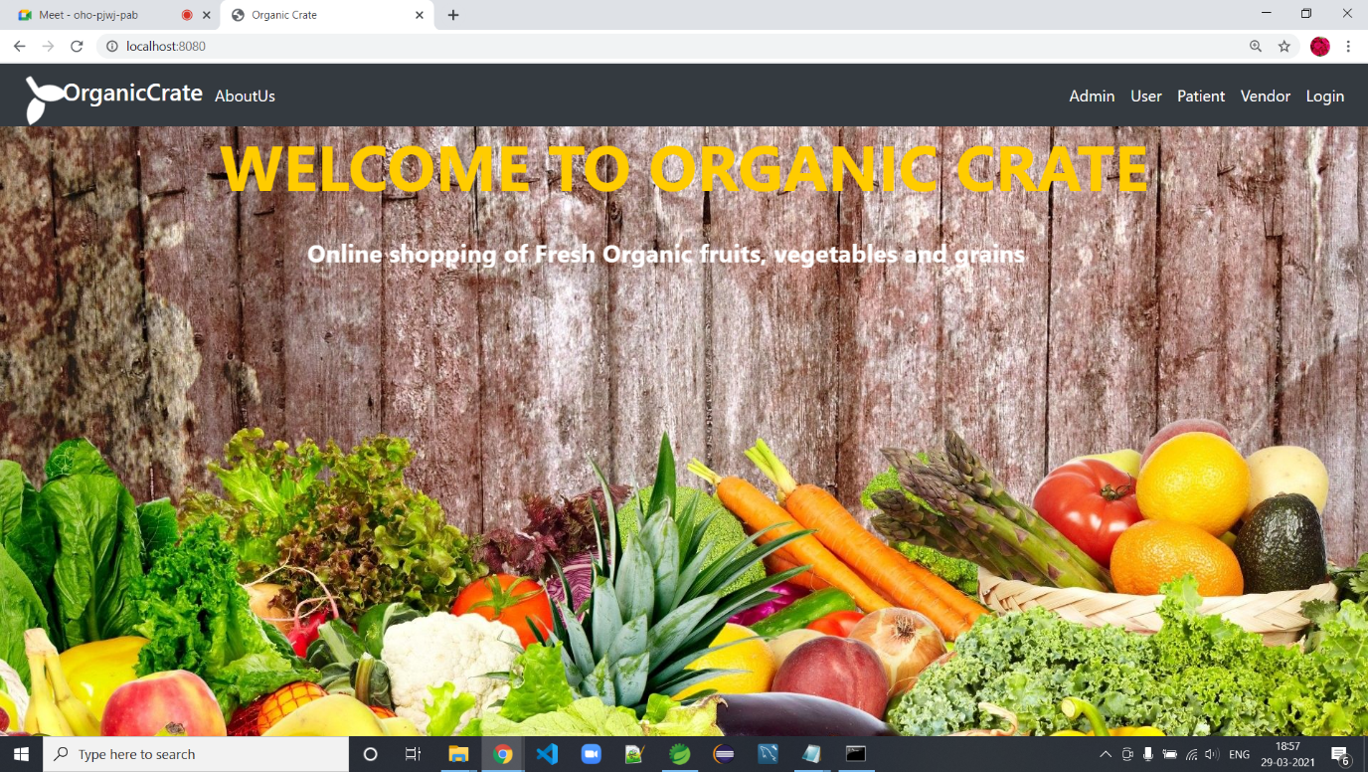

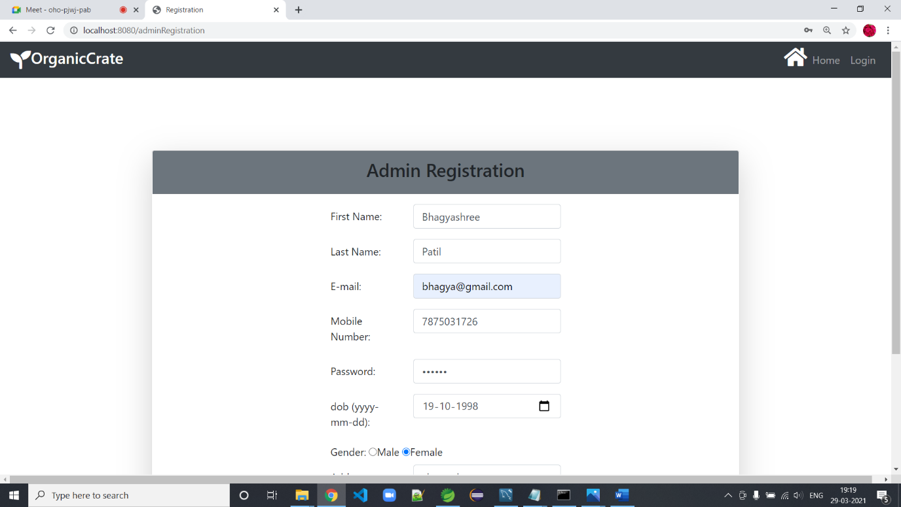

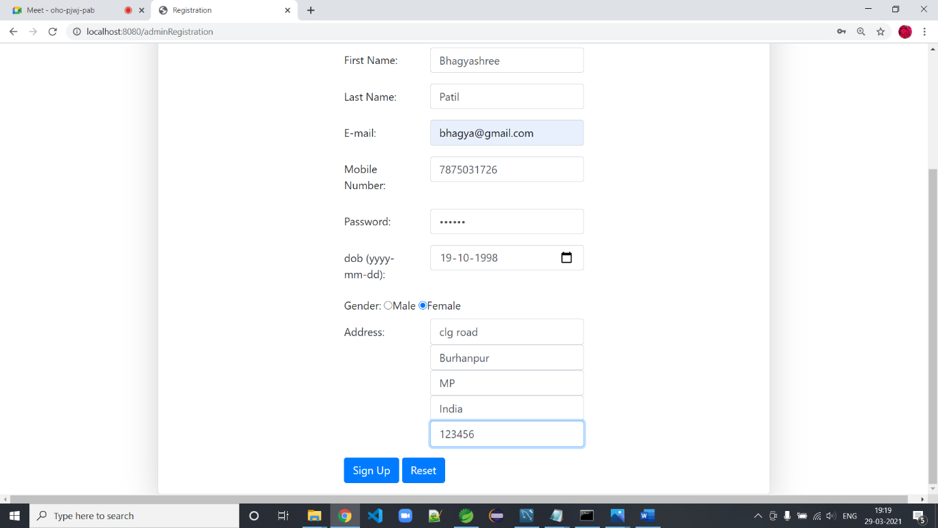

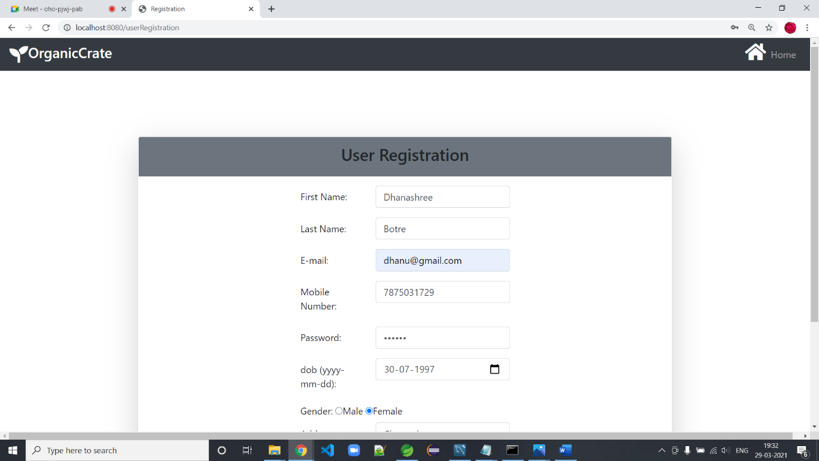

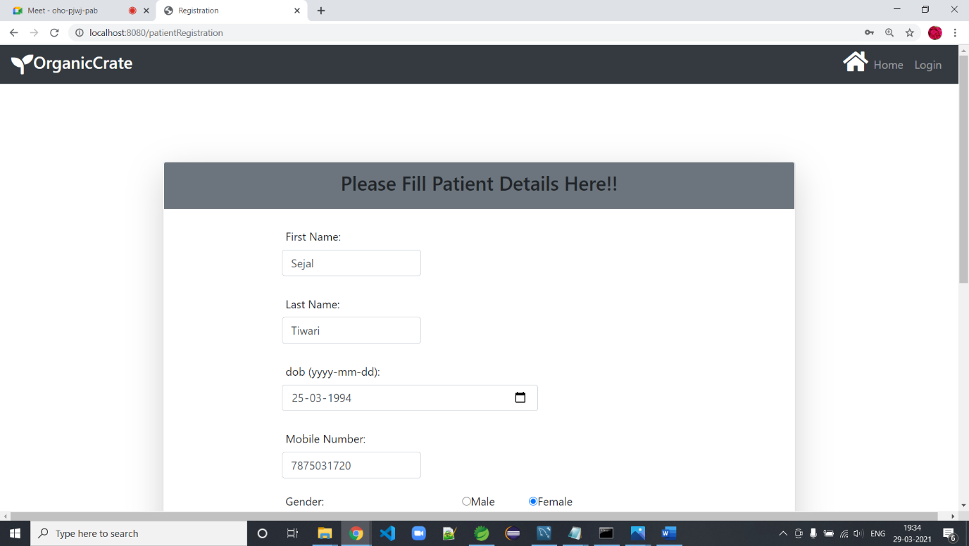

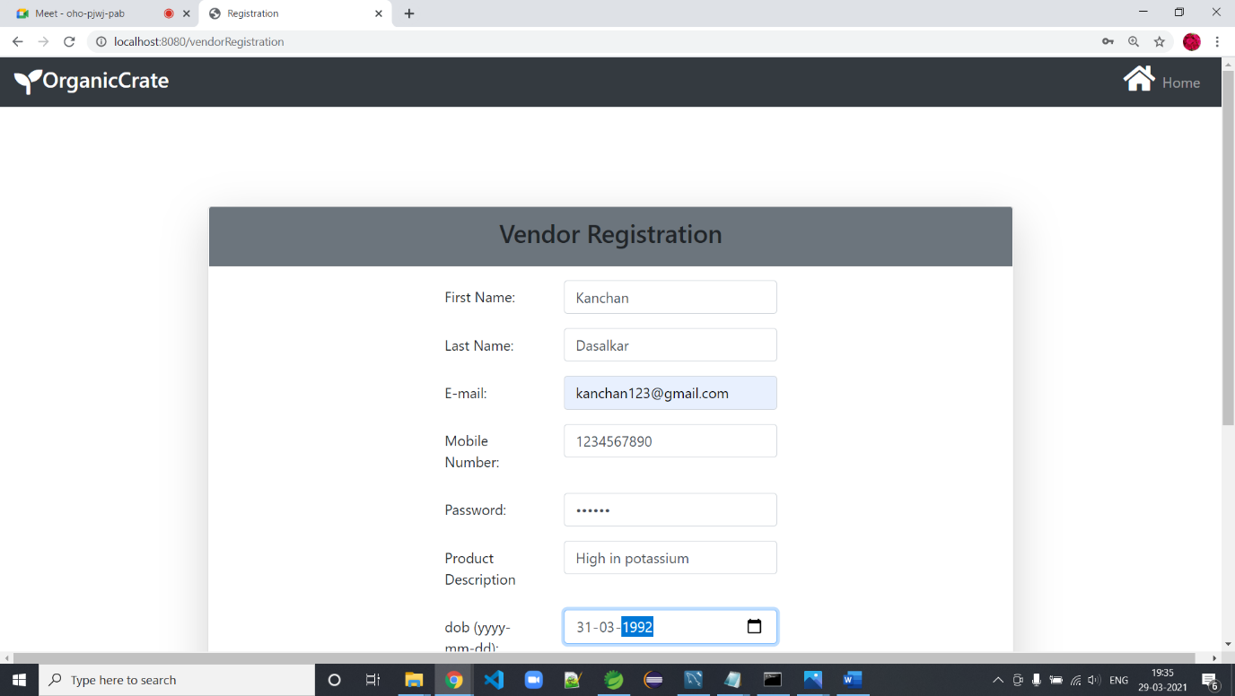

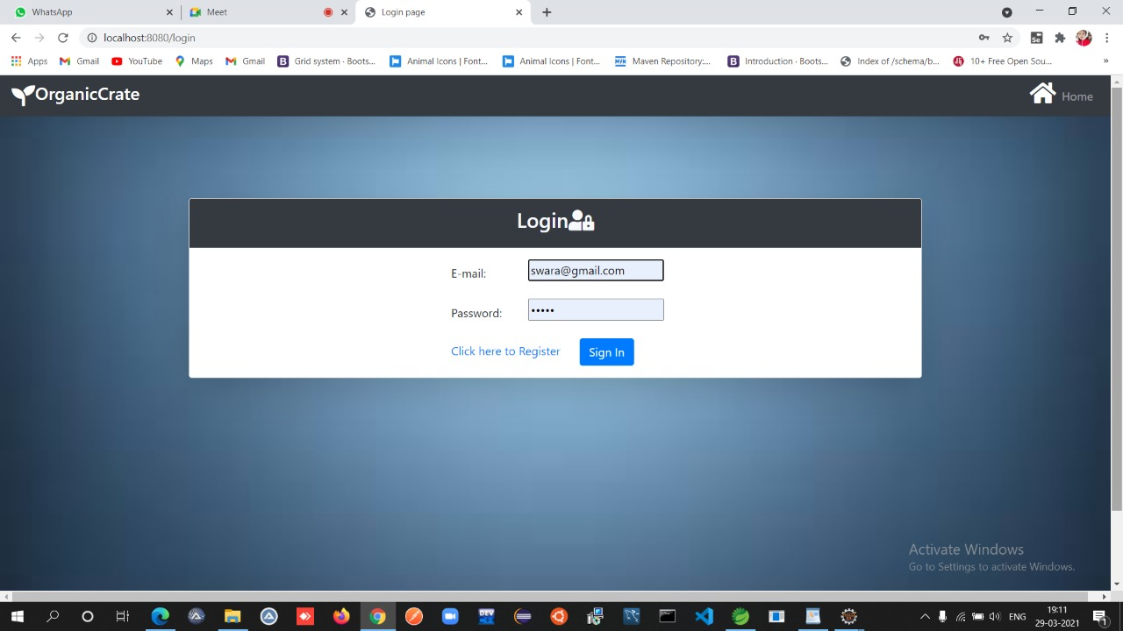

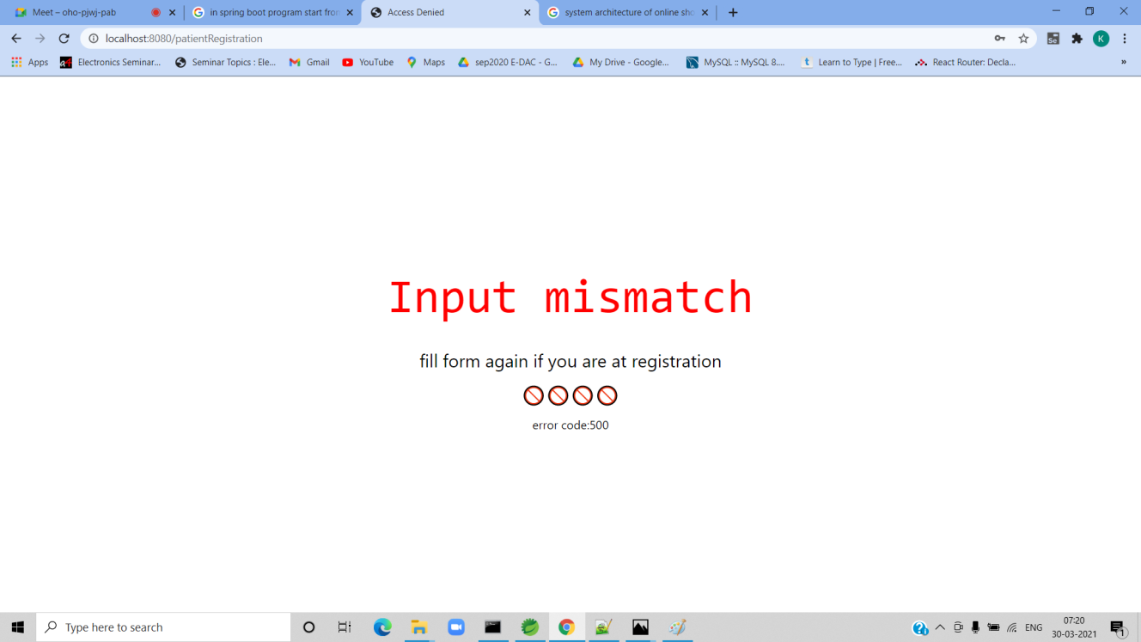

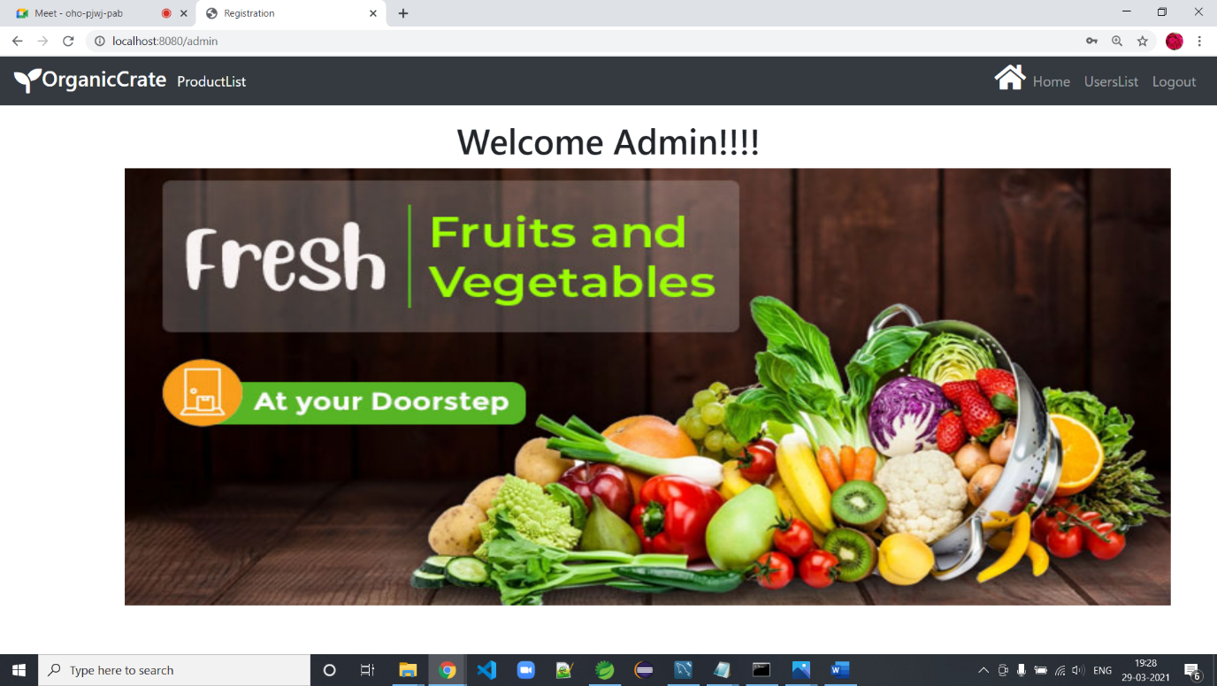

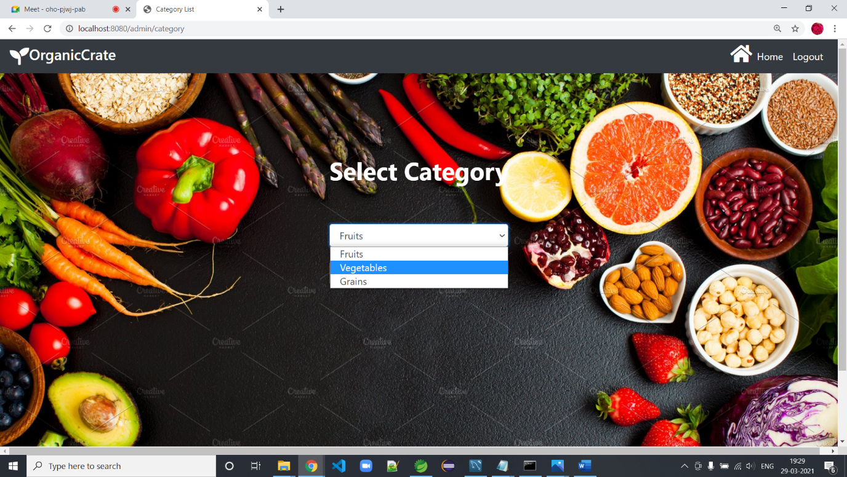

Admin Product List(Actions Available)

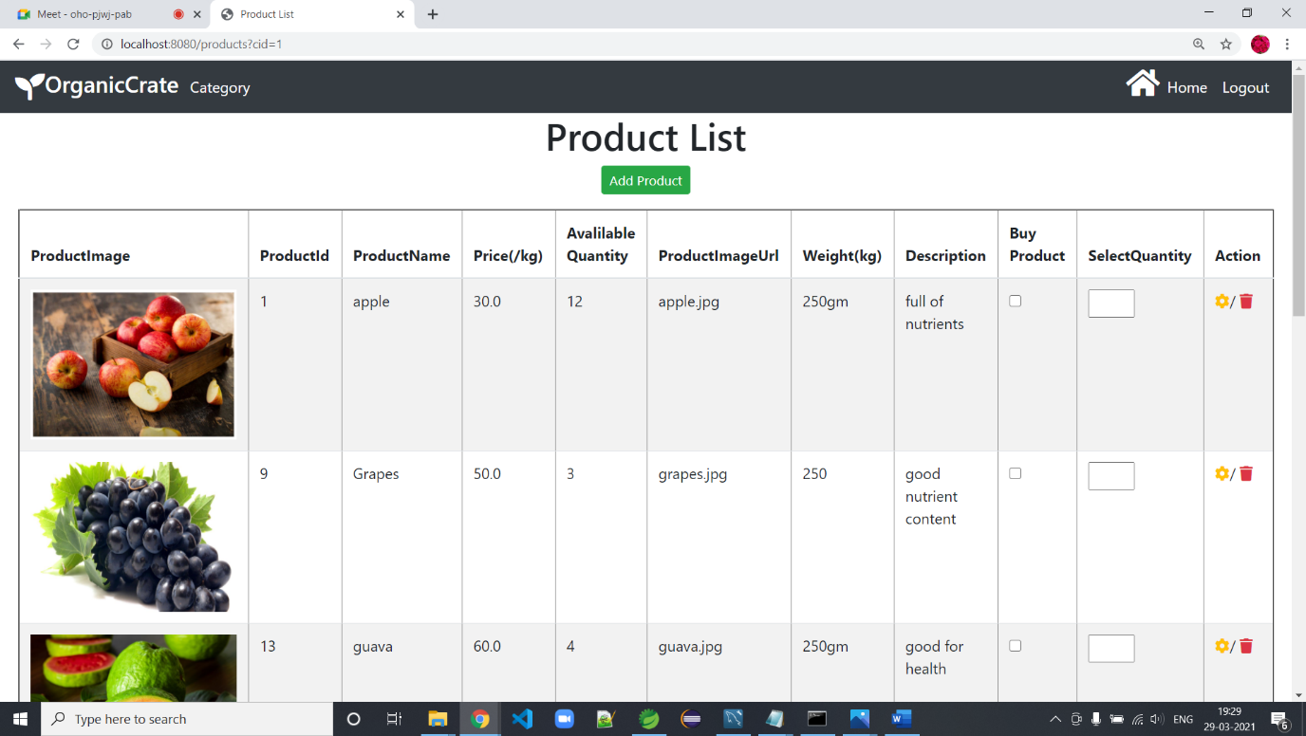

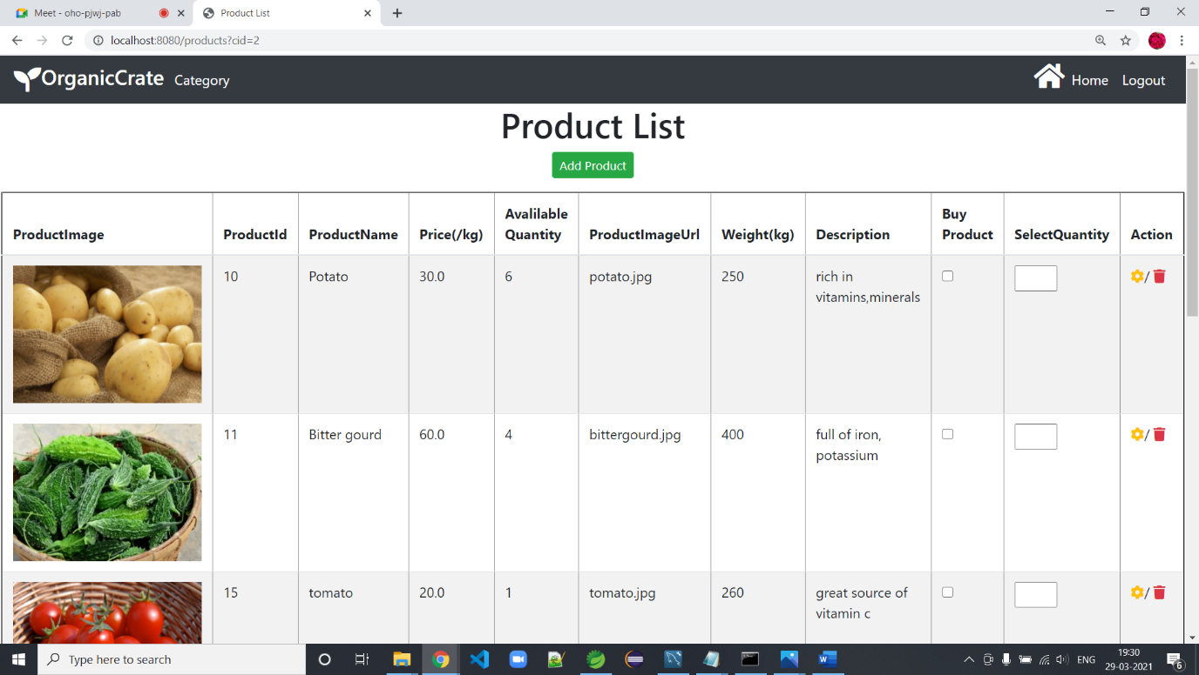

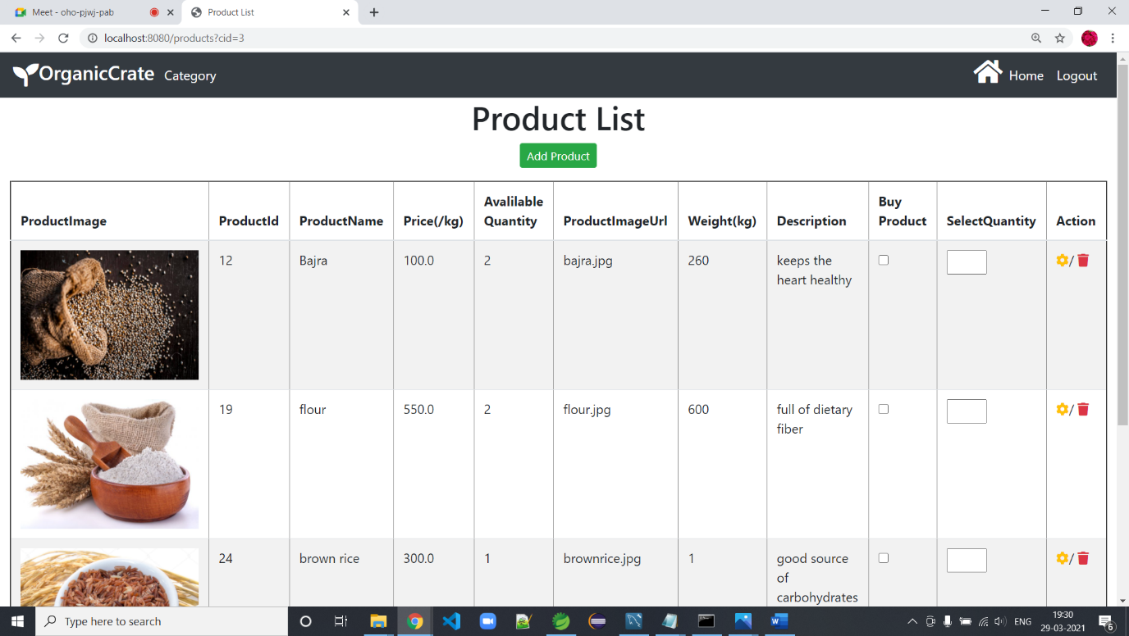

Patient, User & Vendor Product List

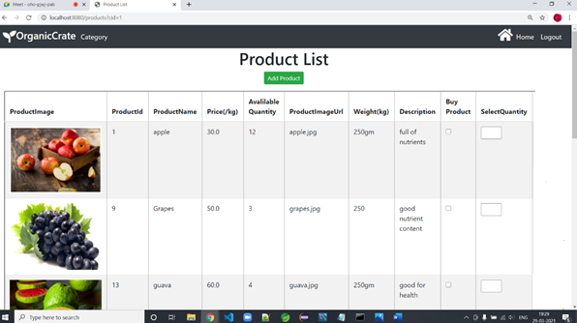

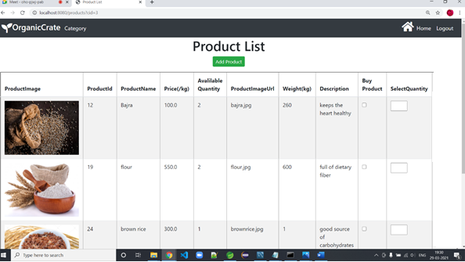

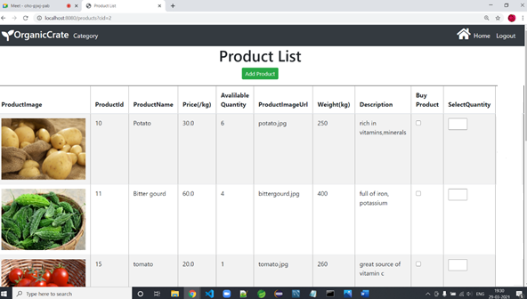

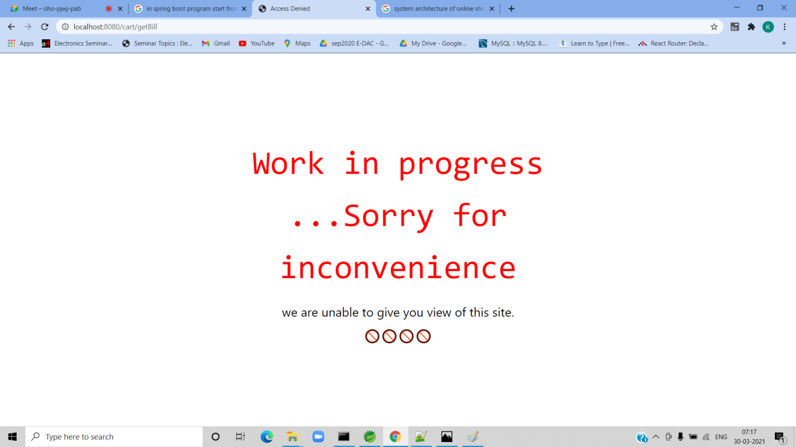

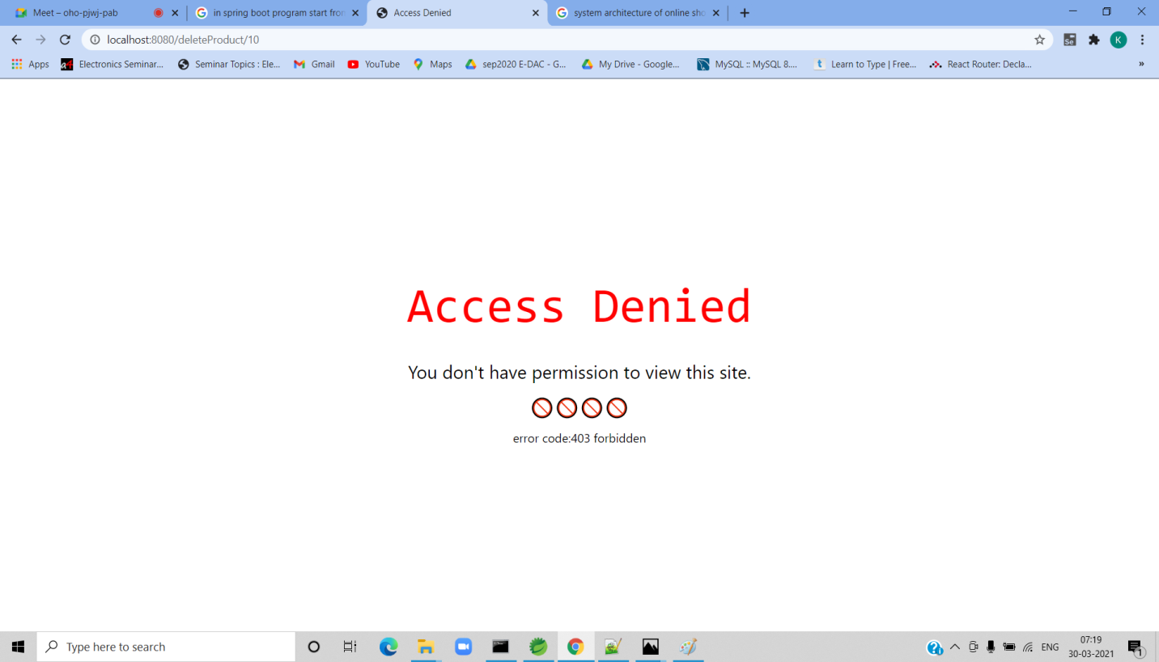

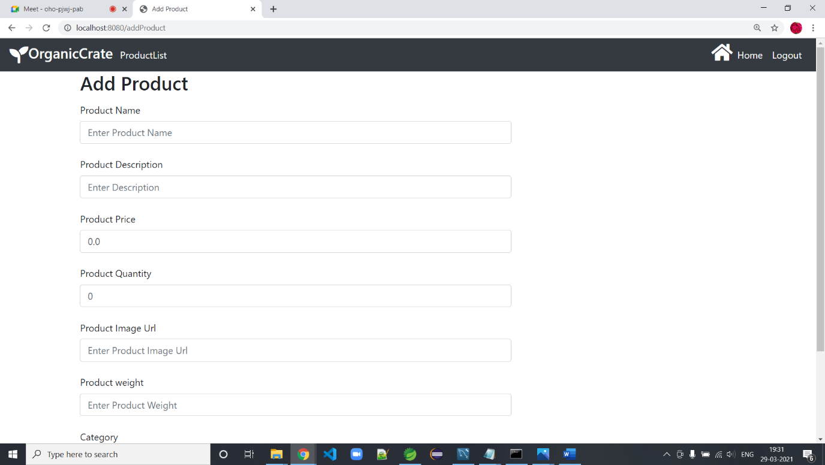

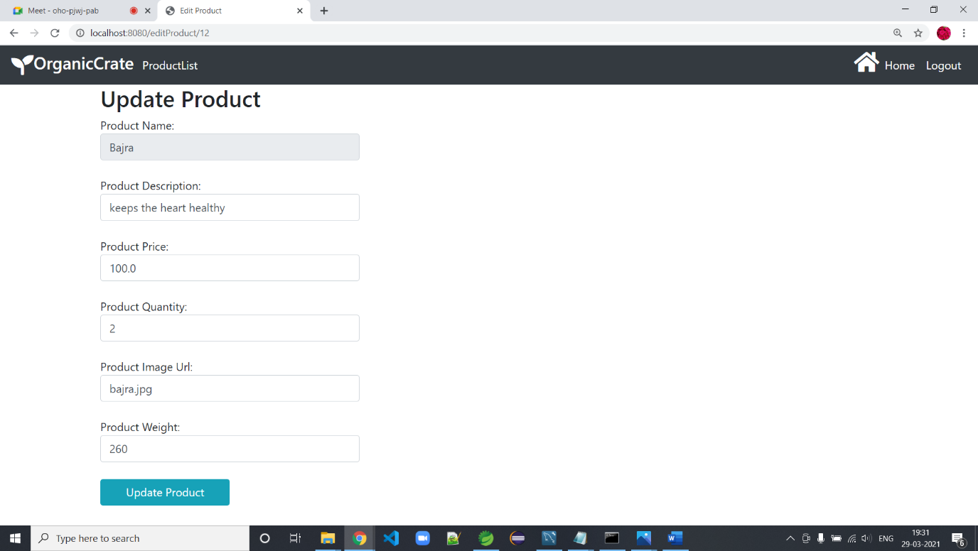

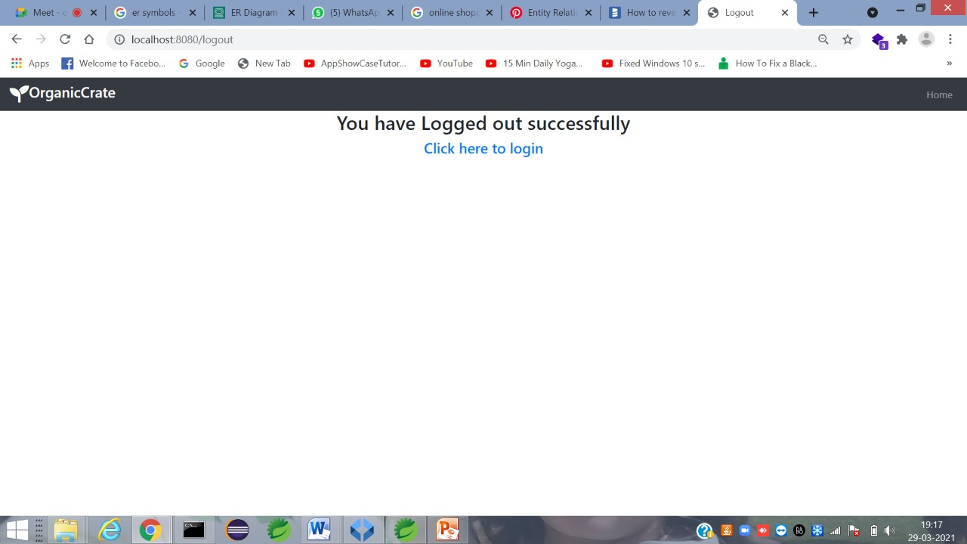

**9. References**

<https://www.conceptdraw.com/How-To-Guide/uml-component-diagram-example-online-shopping>

<https://www.slideshare.net/pujithaboggarapu/grocery-management-system>

Regex @pattern

https://docs.oracle.com/cd/E19798-01/821-1841/gkahq/index.html

annotation for @size

[https://www.baeldung.com/jpa-size-length-column-differences#:~:text=Let's%20use%20the%20length%20attribute,result%20in%20an%20SQL%20error](https://www.baeldung.com/jpa-size-length-column-differences" \l ":~:text=Let's%20use%20the%20length%20attribute,result%20in%20an%20SQL%20error)

basic annotation

<https://springframework.guru/spring-framework-annotations/>

Authorization spring=

<https://www.journaldev.com/8748/spring-security-role-based-access-authorization-example>

Thymleaf html pages

<https://frontbackend.com/thymeleaf/spring-boot-bootstrap-thymeleaf-radio-button>

THYMLEAF

[https://www.thymeleaf.org/doc/tutorials/2.1/thymeleafspring.html#building-uris-to-controllers](https://www.thymeleaf.org/doc/tutorials/2.1/thymeleafspring.html" \l "building-uris-to-controllers)

thymleaf code

<https://www.codejava.net/frameworks/spring-boot/spring-boot-thymeleaf-form-handling-tutorial>

Spring Boot + Spring Security with JPA authentication and MySQL from scratch - Java Brains

http://websystique.com/spring-security/spring-security-4-method-security-using-preauthorize-postauthorize-secured-el/

handlerSuccess

<https://www.codejava.net/frameworks/spring-boot/spring-security-authentication-success-handler-examples>

<https://www.javadevjournal.com/spring/spring-security-success-handler/>

<https://stackoverflow.com/questions/36286112/authenticationsuccesshandler-in-spring-security>

<https://javapointers.com/spring/spring-security/spring-custom-authenticationsuccesshandler-example-2/>

<https://www.codejava.net/frameworks/spring-boot/spring-security-authentication-failure-handler-examples>

imagethymleaf

<https://stackoverflow.com/questions/51083414/cant-load-image-with-spring-boot-thymeleaf>

https://memorynotfound.com/adding-static-resources-css-javascript-images-thymeleaf/